# Pre Sprint

## First Client Sit-Down Meeting

Overall aim for the project

* Profit
  + System makes monies from stock market
  + Build a system to connect to a stock market database
    - Buy/sell shares for max profit on that system

What features would you like to be implemented first?

* No preference on what *features* first
* Features that must happen by the end
  + Buy and sell shares manually
  + Automated feature to buy and sell most profitable shares (i.e. for next 24 hours)
  + Must be an interface of some kind (GUII or CMD)

Before the end product, would you want to see any/all iterations?

* Yes, every week
* Checking that we meet targets
  + Connect to test server
  + Buy and sell from test server
  + Can make profit

What is the products due date?

* Assignment Deadline

Are there any security features (safety) required?

* Don’t want to end up losing money
  + Makes sure it doesn’t make bad decisions.

What sort of feedback from the system would you like?

* Tell me what shares its bought and sold (timestamps, logs etc)
* Prediction feature.

How often would you like the system to feedback to you?

* At the end, when it’s finished.

Test server notes:

* 100 different companies
* Client has no morals
* Live 0900am on Monday 26th

## Requirements

* By the end, the program must have an interface and be able to handle manual buying & selling stocks from the test server and have an automated buying & selling system too
* Must also feedback what has been bought and sold at the end of the session
* Potential to add a predicted outcome feature
* No preference on which features to be implemented first but must be able to connect to test server by next week
* Profit is the most important
* Iterations once per week until assignment deadline
* Automated buying and selling must NOT lose money

# Sprint 1 – 23/10/2015 – 30/10/2015

## Sprint Planning

### User Stories

Create Socket: Program connects to the Stock Market server and is able to send commands and read replies from the server. – Priority: Need – Time: 2 hours

Testing Socket Code: Test the Program to make sure it is free from exceptions and is fully useable so development of the system can continue. – Priority: Should – Time: 1 hours

Create Sprint Documentation: Create the documentation for the sprint. – Priority: Should – Time: 2 hours

UI Design: Design the user interface for the system. – Priority: Could – Time: 1 hours

### Tasks

* Create Socket
  + Create socket code to connect to server.
  + Create socket code to clean exit from server.
  + Create socket code to receive code to receive from server.
* Testing Socket Code
  + Write test cases for testing socket.
  + Test the code using test cases.
* Create Socket Code
  + Verb-noun Analysis.
  + Domain Analysis.
  + Conceptual Classes.
* UI Design
  + Design Paper Prototype.

### Roles

|  |  |  |
| --- | --- | --- |
| Member | Role | Tasks Assigned |
| Tom | Scrum Master | Manage team. |
| Jacob | Programming | Create socket code to connect to server. |
| Mitchell | Programming | Create socket code to clean exit from server. |
| Scott | Programming | Create socket code to receive from server. |
| Rob | UI Design | Write test cases for testing socket.  Test the code using test cases. |
| Rebeka | Documentation | Verb-noun Analysis.  Domain Analysis.  Conceptual Classes |
| Adam | Testing | Design Paper Prototype. |

## Stand Up Meeting

### What do you plan to complete by next meeting?

Jacob – “To establish a connection to the server.”

Mitchell – “To be able to send commands to the server.”

Scott – “To be able to receive replies from the server.”

Rob – “To design an interface for the system.”

Rebeka – “To document the code using UML and to complete the Log.”

Adam – “To write a test plan and then test according to the test plan once code is completed.”

### What is getting in your way?

Jacob – “Lack of knowledge on Sockets within Java.”

Mitchell – “Having to adjust to Java Development and not having much knowledge of networking.”

Scott – “No knowledge of Java.”

Rob – “Doesn’t know how an implementation in Java will be limited to.”

Rebeka – “Determining the best way to approach the design of the system.”

Adam – “Having to develop a test plan for a developing system.”

## Task Board

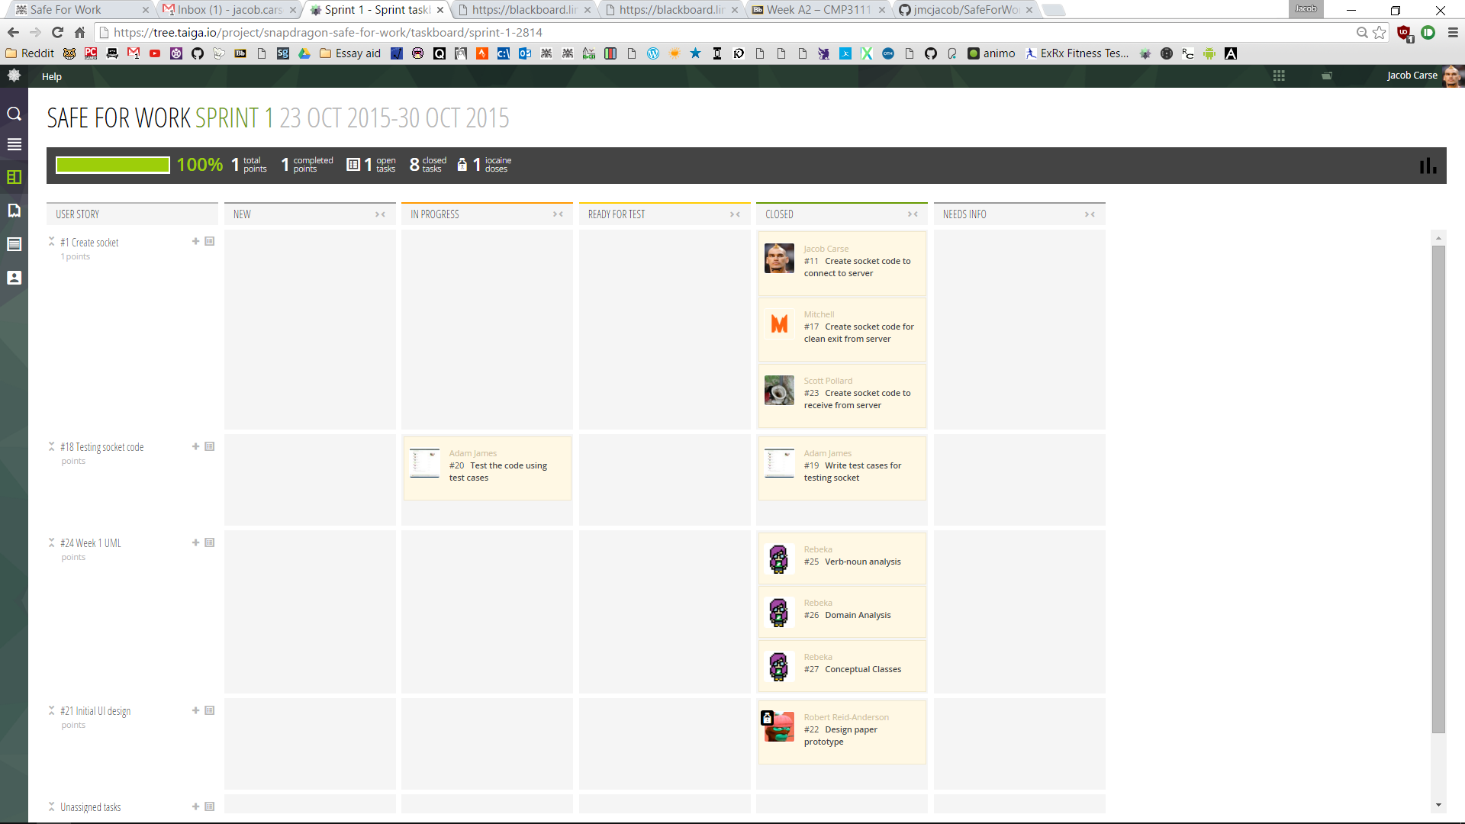

## Pair Programming Logs

|  |  |
| --- | --- |
| Person 1 | Jacob Carse (80% Driver) |
| Person 2 | Mitchell Bellamy (20% Driver) |
| Date | 30/10/2015 |
| Length | 2 Hours |
| Tasks | Create socket code to connect to server.  Create socket code to clean exit from server.  Create socket code to receive code to receive from server. |
| Code | https://github.com/jmcjacob/SafeForWork/commit/8bf81c311c833bee86d272a4acbe062492ff749e |

## Log

# Sprint 2 – 30/10/2015 – 6/11/2015

## Sprint Planning

### User Stories

Thread System: To add asynchronous processing to the receive and send classes. – Priority: Should – Time: 2 hours

Testing System: Test the Program to make sure it is free from exceptions and is fully useable so development of the system can continue. – Priority: Should – Time: 1 hours

Create Sprint Documentation: Create the documentation for the sprint. – Priority: Should – Time: 2 hours

Investigate UI Implementation: Investigate how a UI would be implemented in Java. – Priority: Could – Time: 1 hours

### Tasks

* Thread System
  + Add Threading to the Server.
* Testing Socket Code
  + Write Test Plan.
  + Test According to Plan.
* Produce Sprint Documents
  + Produce UML for the System.
* UI Design
  + Investigate GUI in Java development.

### Roles

|  |  |  |
| --- | --- | --- |
| Member | Role | Tasks Assigned |
| Jacob | Scrum Master | Manage team. |
| Rebeka | Programming | Add Threading to the Server. |
| Tom | Programming | Add Threading to the Server. |
| Mitchell | Testing | Write Test Plan.  Test According to Plan. |
| Rob | UI Research | Investigate GUI in Java development. |
| Scott | Documentation | Produce UML for the System. |
| Adam | UI Research | Investigate GUI in Java development. |

## Stand Up Meeting

### What have you completed since the last meeting?

Jacob – “Establish a connection to the server with the ability to read and write.”

Mitchell – “The system can now connect to the server and communicate using two classes for reading and writing.”

Scott – “The program reads the replies and then can exit without any errors in the system.”

Rob – “A paper prototype of the designed user interface was created.”

Rebeka – “Fully documented the current iteration of the system.”

Adam – “Testing plan were written but the testing wasn’t able to be carried out due to errors download the system.”

### What do you plan to complete by next meeting?

Tom – “To implement the reading and writing classes within threads.”

Mitchell – “To produce a testing plan that will cover the whole system and to then carry out the testing.”

Scott – “To write the UML based on the system to give people insight on how the system works.”

Rob – “To instigate how to develop a user interface within a java development so the design can be implemented.”

Rebeka – “To make the sending and receiving work in a different thread to the main program.”

Adam – “To research how to make a GUI in java that can work with the system.”

### What is getting in your way?

Tom – “No experience with Java development.”

Mitchell – “The program needs to be finished for the testing to begin.”

Scott – “I need to understand the system before the UML can be completed.”

Rob – “I need to understand how user interfaces work in order to figure out how to implement a java one.”

Rebeka – “No knowledge of how threading works or how it is implemented within Java.”

Adam – “Never done Java before.”

## Task Board

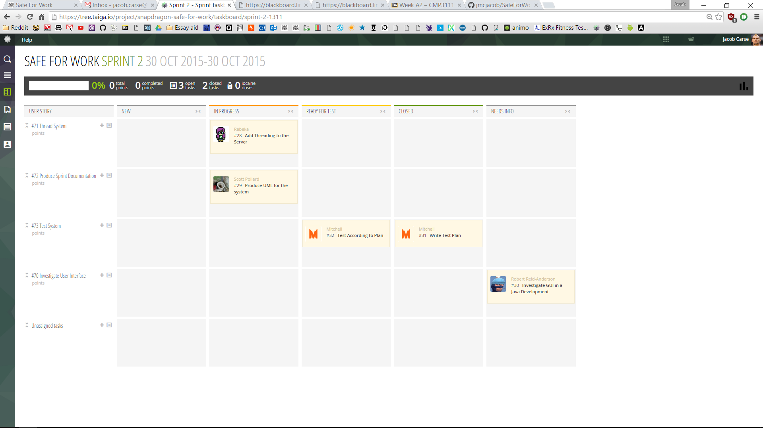

## Pair Programming Logs

|  |  |
| --- | --- |
| Person 1 | Rebeka Lewis (100% Driver) |
| Person 2 | Tom Rowell (100% Navigator) |
| Date | 6/11/2015 |
| Length | 2 Hours |
| Tasks | Add Threading to the Server. |
| Code | https://github.com/jmcjacob/SafeForWork/commit/d035ae1a3a26654340453f2d6c70326ed303a518 |

## Log

# Sprint 3 –6/11/2015 – 13/11/2015

## Sprint Planning

### User Stories

Create new UML: Rewrite UML to fit the new design pattern. – Priority: Could – Time: 1 hours

Make code Register: Make the program run the register command on the server. – Priority: Need – Time: 2 hours

Implement Facade Pattern: Create the documentation for the sprint. – Priority: Should – Time: 4 hours

Test new functionality: Test the new methods that have been implemented into the system. – Priority: Should – Time 2 hours

Investigate GUII Implementation: Investigate how a GUII is implemented in Java. – Priority: Could – Time: 1 hours

### Tasks

* Create new UML.
  + Create UML for Façade.
* Make code Register
  + Revise Code for reading and writing
  + Implement REGI
* Implement Façade
  + Add the Façade
* Test new Functionality
  + Write Test Cases for Façade
  + Test Façade
* Investigate GUII
  + Investigate GUII Implementation

### Roles

|  |  |  |
| --- | --- | --- |
| Member | Role | Tasks Assigned |
| Rebeka | Scrum Master | Manage team. |
| Jacob | Programming | Revise Code for reading and writing  Add the Façade |
| Tom | UI Research | Investigate GUII Implementation. |
| Mitchell | Programming | Revise Code for reading and writing  Implement REGI |
| Rob | Testing | Write Test Cases for Façade  Test Façade |
| Scott | Documentation | Create UML for Façade. |
| Adam | UI Research | Investigate GUII Implementation. |

## Stand Up Meeting

### What have you completed since the last meeting?

Tom – “Most of the code is done but it not yet working.”

Mitchell – “The test plans were written but the application wouldn’t compile so testing couldn’t be completed.”

Scott – “Because the system wasn’t working the UML couldn’t be finished but was started.”

Rob – “Implementing a GUI in Java is more difficult than expected.”

Rebeka – “The system is having a problem passing the socket into the new threads.”

Adam – “No useful materials were found for implement a GUI in Java.”

### What do you plan to complete by next meeting?

Tom – “Find a simple way of implementing a Java GUI with the Façade.”

Mitchell – “To fix the reading and writing classes and to implement a register method.”

Scott – “To Finish the UML that was started in the previous week and to make it include the Façade.”

Rob – “To write a test plan to make sure the Façade is fully operational.”

Jacob – “Make the current implementation of the code run through a Façade.”

Adam – “To revise the previously found materials for anything useful for a GUI working with a Façade.”

### What is getting in your way?

Tom – “The Façade not being complete may be hard to find how to implement a GUI for the Façade.”

Mitchell – “No previous knowledge of threading in a Java development environment.”

Scott – “No idea on how to represent a Façade in UML.”

Rob – “Testing was not completed in the previous weeks so the system may not be funny operational.”

Jacob – “Shouldn’t be a problem with implement the current system in a Façade as long as the threading is working.”

Adam – “To try and figure out how to implement the Façade pattern with a GUI.”

## Task Board

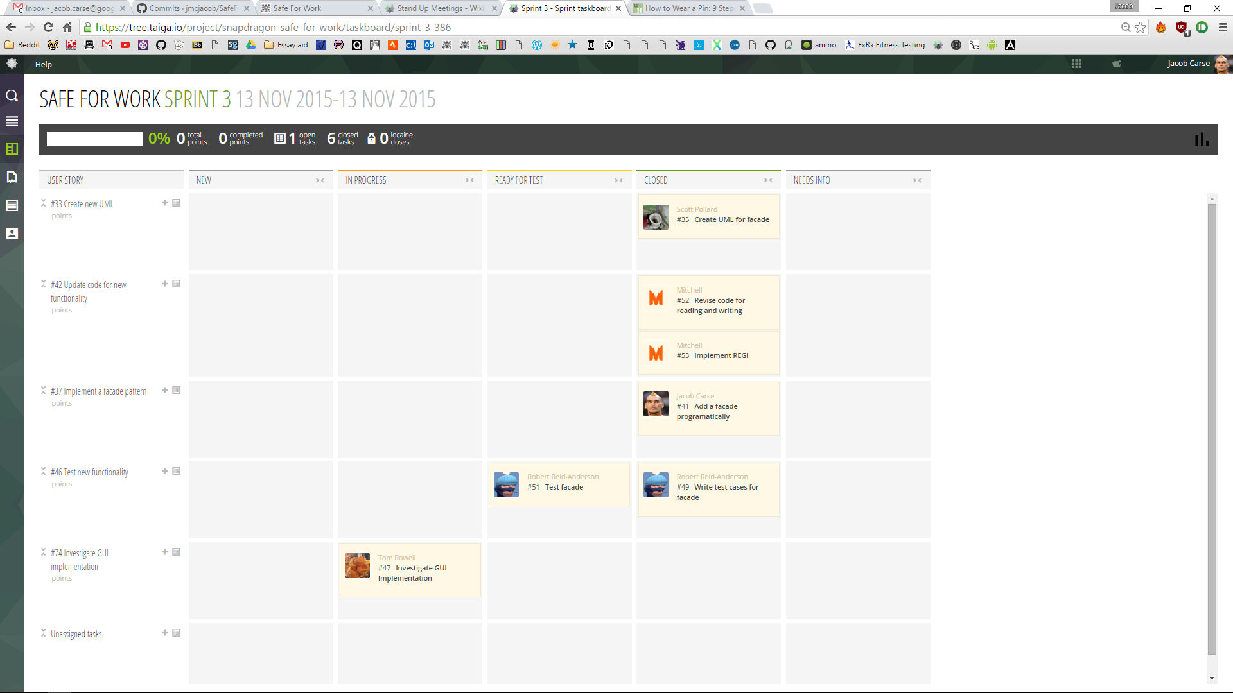

## Pair Programming Log

|  |  |
| --- | --- |
| Person 1 | Mitchell Bellamy (70% Driver) |
| Person 2 | Jacob Carse (30% Driver) |
| Date | 13/11/2015 |
| Length | 2 Hours |
| Tasks | Revise Code for reading and writing |
| Code | https://github.com/jmcjacob/SafeForWork/commit/502438a07acfc053a61357953c6ea599002ab87e |

## Log

# Sprint 4 –13/11/2015 – 20/11/2015

## Sprint Planning

### User Stories

Implement Clean Room Programming: To make the code that is uploaded to Github adhere to the fundamentals of Clean Room Programming. – Priority: Should – Time: 2 Hours

Investigate UI in Java: To confirm that all the materials to implement a UI in Java have been gathered. – Priority: Could – Time: 2 Hours

### Tasks

* Implement Clean Room Programming
  + Convert Project to Clean Room Programming
* Investigate UI in Java
  + UI Research

### Roles

|  |  |  |
| --- | --- | --- |
| Member | Role | Tasks Assigned |
| Scott | Scrum Master | Manage team. |
| Jacob | Programming | Convert Project to Clean Room Programming |
| Tom | UI Research | UI Research |
| Mitchell | Programming | Convert Project to Clean Room Programming |
| Rob | UI Research | UI Research |
| Adam | UI Research | UI Research |
| Rebeka | Unavailable |  |

## Stand Up Meeting

### What have you completed since the last meeting?

Scott – “Unfortunately producing the documentation was harder than first imagined so Rebeka took over after the initial steps.”

Jacob – “Created a Façade for the program to run through.”

Tom – “Found some relevant materials on how to develop a UI in Java but needs to be expanded on.”

Mitchell – “The system can now register with the server and retrieve an ID.”

Rob – “The test cases were written but the server was not available so the testing couldn’t be performed.”

Adam – “Materials were gathered but all options need to be researched.”

### What do you plan to complete by next meeting?

Jacob – “Move all the code out of an IDE project and into a Clean Room project with just the java files.”

Tom – “Have all the materials together in order to develop a UI.”

Mitchell – “Implement the principles of clean room programming into the project.”

Rob – “To refine all UI documents so development of a UI can begin.”

Adam – “To make sure that a UI can be developed by gathering all materials.”

### What is getting in your way?

Jacob – “Having to replace the code onto Github may require skills with Git I have lacking knowledge of.”

Tom – “Knowing what materials are relevant to developing the UI.”

Mitchell – “To figure out how to compile the code from clean room programming.”

Rob – “Understanding how to develop a UI with clean room programming.”

Adam – “How adding libraries into Java with clean room programming.”

## Task Board

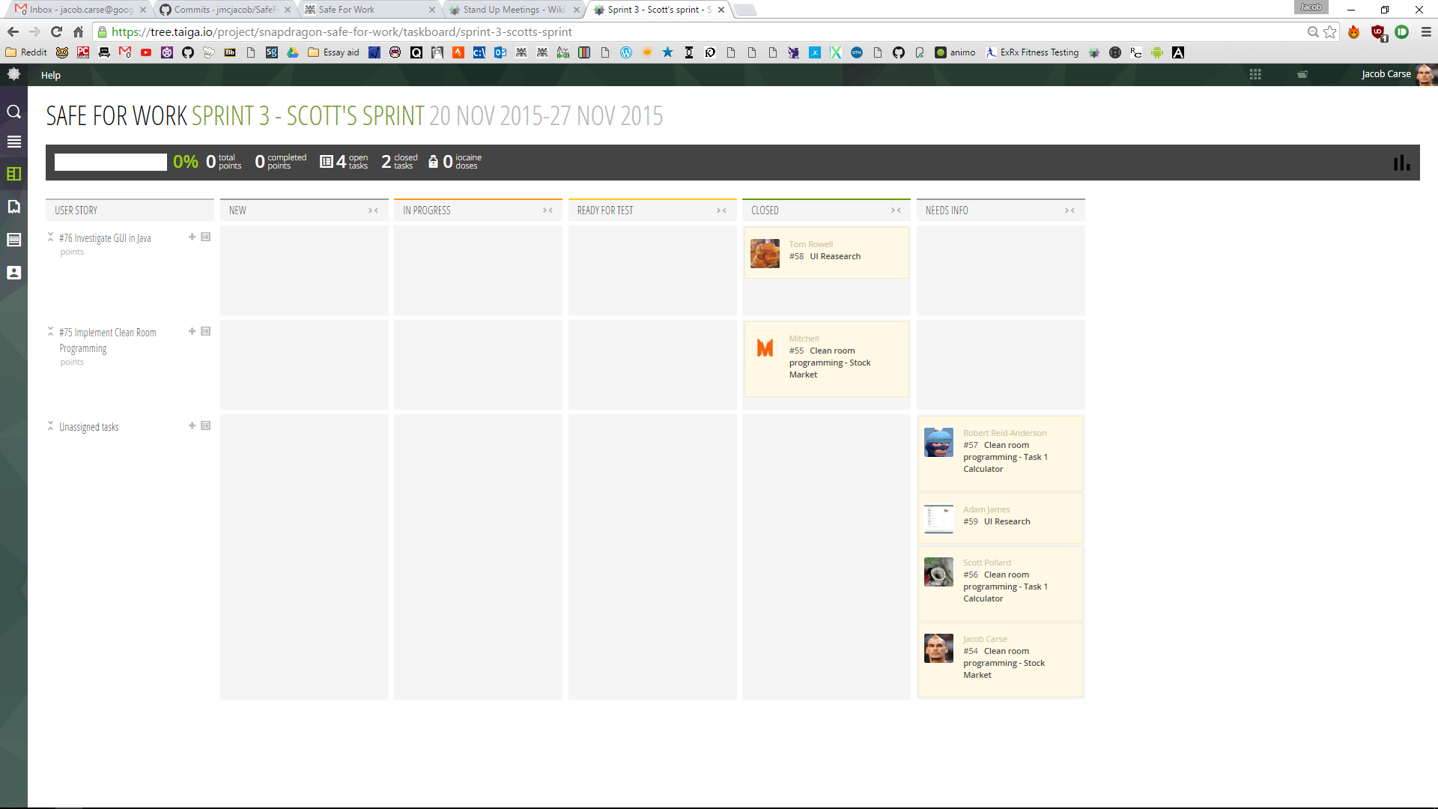

## Pair Programming Log

|  |  |
| --- | --- |
| Person 1 | Mitchell Bellamy (50% Driver) |
| Person 2 | Jacob Carse (50% Driver) |
| Date | 20/11/2015 |
| Length | 2 Hours |
| Tasks | Convert Project to Clean Room Programming |
| Code | https://github.com/jmcjacob/SafeForWork/commit/ae46712cc626d7d0bc2ba854605ad732af16b205 |

## Log

# Sprint 5 – 20/11/2015 – 27/11/2015

## Sprint Planning

### User Stories

Implement Display Method: To create a method that will display the details of all stocks from the server. – Priority: Need – Time: 4 Hours

Implement Buy and Sell Methods: To Create methods to buy and sell stock in the server. – Priority: Need – Time: 4 Hours

Update Documentation: To update all the documentation for the project bringing it up to date. – Priority: Should – Time: 2 Hours

### Tasks

* Implement Display Method
  + Test Register Method
  + Implement Display Method
* Implement Buy and Sell Methods
  + Implement Buy Method
  + Implement Sell Method
* Update Documentation
  + Construct UML
  + Update Blog

### Roles

|  |  |  |
| --- | --- | --- |
| Member | Role | Tasks Assigned |
| Mitchell | Scrum Master | Manage team. |
| Jacob | Programming | Test Register Method  Implement Display Method |
| Tom | Programming | Implement Buy Method  Implement Sell Method |
| Scott | Documentation | Update Blog and Logs |
| Rob | Programming | Implement Buy Method  Implement Sell Method |
| Adam | Documentation | Construct UML |
| Rebeka | Programming | Test Register Method  Implement Display Method |

## Stand Up Meetings

### What have you completed since the last meeting?

Jacob – “Implemented clean room programming to work with the system.”

Tom – “Didn’t get any materials on how to develop a user interface in clean room programming.”

Mitchell – “Uploaded all the clean room programming onto Github.”

Rob – “All the user interfaces implementation are too complicated for the remaining time scale of the project.”

Adam – “All the user interface are too complex for clean room programming.”

### What do you plan to complete by next meeting?

Jacob – “Make sure the register method is working to send with the display command.”

Tom – “To add buying a selling to the system’s Façade.”

Scott – “To make sure that the blog is updated with all the latest information from Taiga.”

Rob – “To make the buying and selling of stocks is possible within the system.”

Adam – “To make sure that all the UML is up to date with latest iteration of the system.”

Rebeka – “To create a method to display all the available stocks.”

### What is getting in your way?

Jacob – “The lack of testing on previous iterations could cause problems.”

Tom – “Lack of understanding of how the system currently works.”

Scott – “Some aspects of previous sprints may be less detailed and hard to write in a backlog.”

Rob – “Lack of knowledge on how to implement methods in a Façade.”

Adam – “UML is hard to write for a system that isn’t finished.”

Rebeka – “The lack of knowledge on how the server works could cause problems trying to receive and parse the data from the server.”

## Task Board

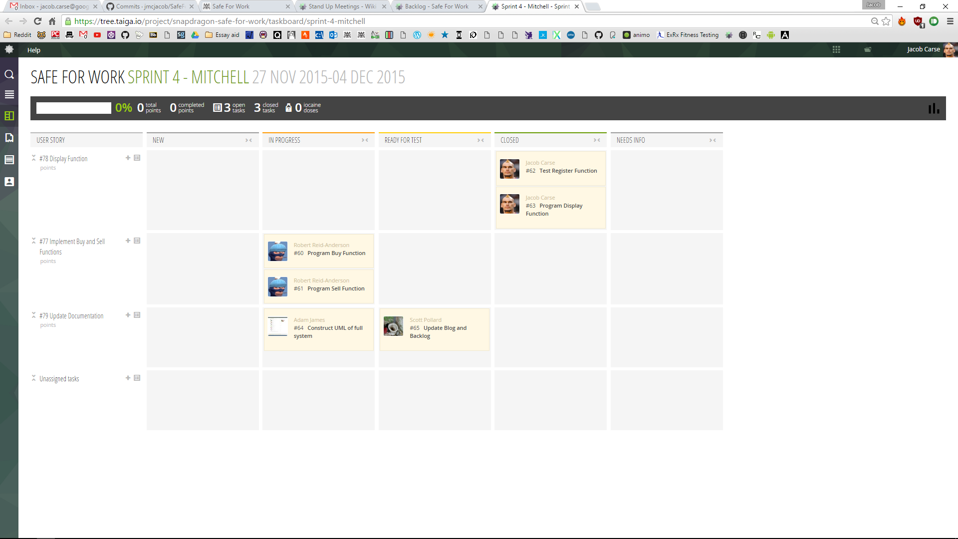

## Pair Programming Logs

|  |  |
| --- | --- |
| Person 1 | Rebeka Lewis (60% Driver) |
| Person 2 | Jacob Carse (40% Driver) |
| Date | 27/11/2015 |
| Length | 2 Hours |
| Tasks | Test Register Method  Implement Display Method |
| Code | https://github.com/jmcjacob/SafeForWork/commit/f5c9d6bc1dfd0f3ee94e47b47b7ea222143dc2b0 |

|  |  |
| --- | --- |
| Person 1 | Robert Anderson (50% Driver) |
| Person 2 | Tom Rowell (50% Driver) |
| Date | 27/11/2015 |
| Length | 2 Hours |
| Tasks | Implement Buy Method  Implement Sell Method |
| Code | https://github.com/jmcjacob/SafeForWork/commit/51c971f8ba92b1f5116e065832fdad0a0462796f |

## Log

# Sprint 6 – 27/11/2015 – 4/12/2015

## Sprint Planning

### User Stories

Test the System: Test the system to ensure its functionality. – Priority: Should – Time: 2 Hours

Write Documentation: To write the documentation for the system and sprint. – Priority: Should – Time: 4 Hours

Implement Buy and Sell: To make sure the system can buy and sell stock. – Priority: Need – Time: 2 Hours

### Tasks

* Test the System
  + Testing
* Documentation
  + Stand up Meeting Minuets
  + UML
  + Domain Modelling
  + Sprint Logs
* Implement Buy and Sell
  + Implement Buy Method
  + Implement Sell Method

### Roles

|  |  |  |
| --- | --- | --- |
| Member | Role | Tasks Assigned |
| Adam | Scrum Master | Manage team. |
| Jacob | Programming | Implement Buy Method  Implement Sell Method |
| Tom | Documentation | Stand up Meeting Minuets |
| Scott | Documentation | Sprint Logs |
| Rob | Testing | Testing |
| Mitchell | Documentation | Domain Modelling |
| Rebeka | Documentation | UML |

## Stand Up Meetings

### What have you completed since the last meeting?

Jacob – “The system can now register with the system successfully then display all the available stocks from the server.”

Tom – “The buy and sell functions weren’t implemented as the reading and writing threads have no documentation.”

Scott – “The Logs have mostly been updated but need to be added to still.”

Rob – “The buying and selling implementation started but was not completed.”

Adam – “The two programmers were struggling so Mitchell and Rebeka offered to take over UML while I aided the programing.”

Rebeka – “All the stocks can be displayed in the system.”

### What do you plan to complete by next meeting?

Jacob – “To finish the implement of the buy and sell functions in the system.”

Tom – “To make sure that all the Stand-up meeting minuets are fully up to date.”

Scott – “To compile and finish all the sprint logs.”

Rob – “To make sure to test to system making sure its bug free.”

Mitchell – “To complete the domain modelling of the system.”

Rebeka – “To complete the UML for the system.”

### What is getting in your way?

Jacob – “The current implementation of buy and sell isn’t finished and works in a manner different from the rest of the system, this will either have to be rewritten or hacked to work.”

Tom – “Some of the information about the stand-up meetings isn’t clear and may be hard to compile.”

Scott – “Some of the materials used throughout the sprints are not clear and may be difficult to then detail.”

Rob – “The system needs to be finished in order to be tested.”

Mitchell – “I haven’t used domain modelling for about 2 years and will need reminded while creating the domain modelling.”

Rebeka – “The current system isn’t finished so may be hard to complete the UML.”

## Task Board

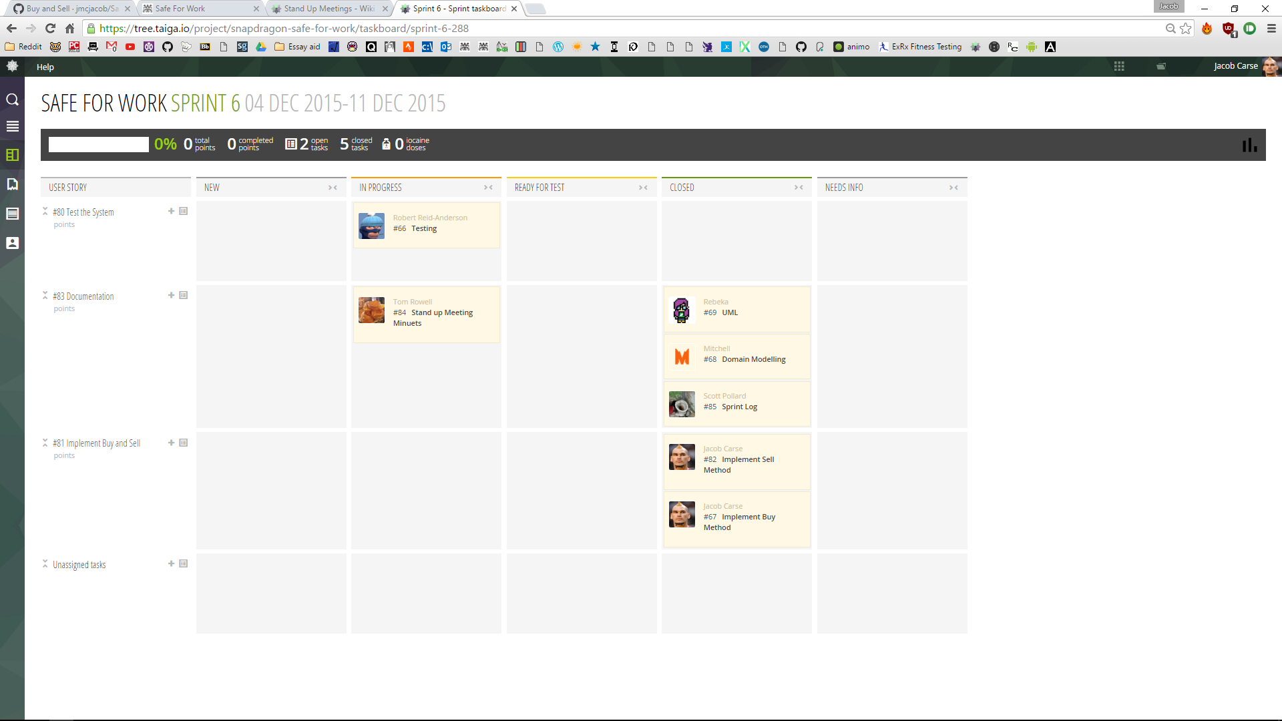

## Log

# Sprint Burn Down